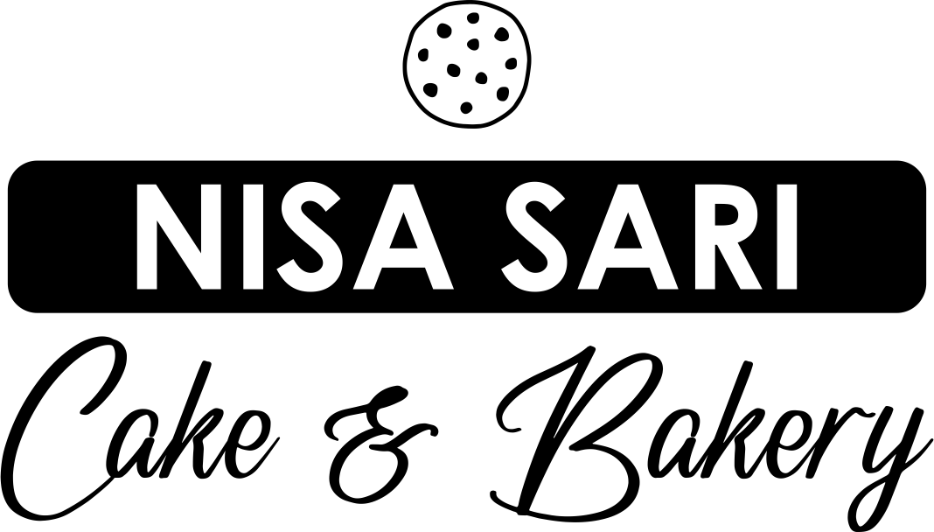

**MAP** : [NISA SARI CAKE & BAKERY](https://www.google.com/maps/place/NISA+SARI+CAKE+%26+BAKERY/data=!3m1!4b1!4m2!3m1!1s0x2dd7e5d5b48bb0e5:0xab46e452545dd2a8)

<https://www.google.com/maps/place/NISA+SARI+CAKE+%26+BAKERY/data=!3m1!4b1!4m2!3m1!1s0x2dd7e5d5b48bb0e5:0xab46e452545dd2a8>

**WEB** : <https://nisa-sari-bakery.business.site/>

**ALAMAT** : JL. NANGKA, STAND ARHANUD NO. 43, Dusun Sruni, Sruni, Kec. Gedangan, Kabupaten Sidoarjo, Jawa Timur 71254

**NOMOR HP** : 0817-0390-0513

**INFO DARI GRAB:** <https://food.grab.com/id/id/restaurant/nisa-sari-bakery-sruni-delivery/6-C2BBNEWJAXUWFA>